Materials in GEOMEC 3

Data-storage tree
The data-storage tree in GEOMEC 3 will contain a main branch called Materials. Below this branch several entries can be created by the user. The materials represented by these entries will actually be maintained by the MatLibX ActiveX control. The user can modify the contents of the material entries by selecting ‘Attributes’ in an entry’s context menu. The material library will have to be modified, so the main dialog is bypassed, and the selected material’s properties will directly be displayed in the ‘Material Parameters’ dialog. In this dialog, the properties can be modified, but the material can not be copied or renamed (i.e. the ‘Save As’ button is not available). It is possible to use the material library’s calibration function in this dialog.
A material entry in the materials branch of the data-storage tree in GEOMEC 3 can be renamed by the user. Therefore, the MatLibX control should export a function, so an existing material (to be defined by its old name) can be renamed. Names have to be unique within the material library, so they also have to be unique in GEOMEC 3.
Materials in the data-storage tree can be imported from or exported to an external material library.

Model tree
A material entry in the data-storage tree can be attached to one or more formations in the ‘Model’ tree. Attaching a material to more than one formation means a share of the material among those formations; if the material is modified, it is modified for all formations that use the material.
The material’s properties (parameter values, model, linear/non-linear) can not be modified in the ‘Model’ tree, they should be modified in the data-storage tree.
If a material has been attached to a formation in the ‘Model’ tree, it will list all its parameters (which parameters depends on the material model chosen in the data-storage tree). The user can attach a distributed property from the data-storage tree to one or more of these parameters. Such a distributed property must have been created in the data-storage tree using the ‘Pointset Attributes’ dialog. If the material attached to the formation is shared among other formations, any distributed property attached to one of the material’s parameters will not be shared among those formations. It only applies to the selected formation.

Storage of the data
The materials and their properties will be stored with the GEOMEC model in the Filos file.

Homogenisation
The user can choose to start a homogenisation process for a selected formation. This can only be done if
- the selected formation contains a material
- the material is linear
- the Young’s modulus and/or the Poisson’s ratio are distributed

The homogenisation process is started from the context menu of the selected formation. Subsequently, the user has to specify one or more block(s) in space, that lie(s) completely inside the selected formation. For each of the specified blocks, the user has to specify the number of elements that will have to be generated in x, y and z direction. GEOMEC will then generate the elements for the blocks and get the (averaged) value for the Young’s modulus and Poisson’s ration for each of the generated elements. All generated meshes (i.e. the blocks) will be transferred to a DIANA kernel that will calculate an equivalent material for each block. These new materials will be presented to the user, who will have several options (see Resulting materials from a homogenisation analysis).

Specification of the homogenisation blocks
To specify the position of the homogenisation the user has to specify a point in a top view of the model. This can be done either graphically or numerically (northing and easting). GEOMEC will then fit a maximum sized cube, inside the selected formation, that contains at least one point, inside the selected formation, of the point distribution per generated element. By default the cube will be divided into 5x5x5 elements, but this can be altered by the user. The dimensions of the cube can be altered graphically or numerically by the user, but each element has to contain at least one point of both the distributed pointsets of the Young’s modulus and the Poisson’s ratio, that lies inside the selected formation.

A validity check on the input of the block (does every element contain at least one point of the distribution(s), that lies inside the selected formation) should be performed after
- modification of the element division
- modification of the size of the box
- modification of the position of the box

Resulting materials from a homogenisation analysis
A homogenisation analysis will return a linear anisotropic material for which the material definition will have to be incorporated into the MatLibX control and the DIANA kernel. The parameters for this material are described through the following elasticity relationship
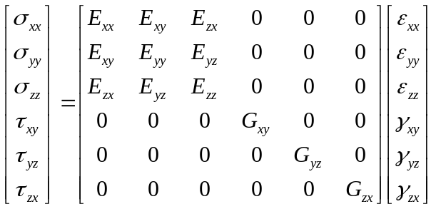

The nine parameters in the matrix are the parameters for this material, where x and y have to replaced by northing and easting respectively.

After the homogenisation analysis, the user is presented with a list of homogenised materials. This list is as long as the number of defined blocks in the formation. Multiple entries can be selected in this list. Actions are
- Apply to formation (only if one of the materials in the list is selected)
- Export to material library (only if one or more materials are selected)
- Copy to data-storage (only if one or more materials are selected)
- Cancel (invoke warning that homogenised materials are lost if they’re not (all) saved to material library or data-storage)

